Date | 16 Feb 2026
Team ID | LTVIP2026TMIDS36006
Project Name | Asset Management Portal using Service Now
Mentor Name | Dr Shaik Salma Begum
Maximum Marks | 10 Marks

Asset Management Portal

Milestone 1: Setting Up ServiceNow Instance:
- Sign up on developer.servicenow.com and create a developer account.
- Navigate to the Personal Developer Instance section and request a new instance.
- Fill out the required information and submit the request.
- Instance details (URL, username, password) will be sent via email.
- Log in to the instance using the provided credentials.
- The instance is ready for development and customization.
Milestone 2: Creation of Table (Asset Inventory):
  - Navigate to All in the application navigator.
  - In the filter search bar, type Tables and select it from the results.
  - 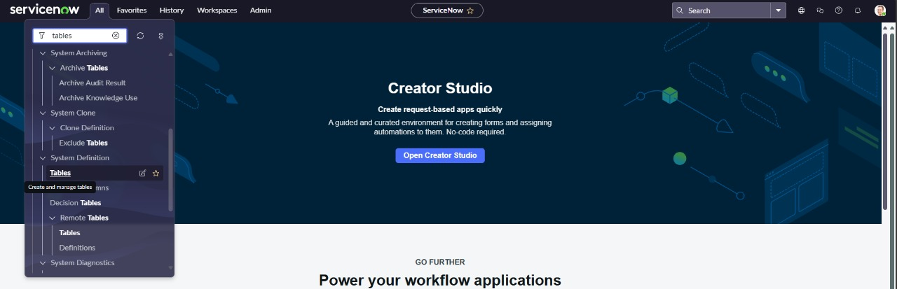
  - Click on the New button to create a new table.
  - In the form, provide the following details:
    - Label: Asset Inventory
    - Name: Auto-Populated (automatically generated based on the label)
    - New menu name: Asset Management Portal
    - 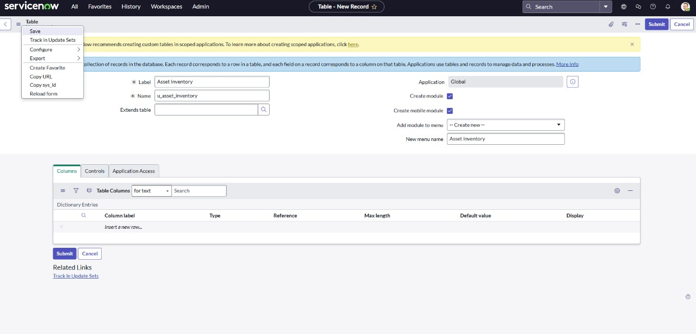
  - Navigate to the header section of the form, right-click on the header, and select Save from the context menu.

Milestone 3: Creation of Fields:
1)After saving the table scroll down
2)Create the following fields
- Assigned to : string
- Status : choice
- Purchase date : date
- Warranty Expire : date
- Asset name : string
- Type : choice
- Number : String
3) Click on save
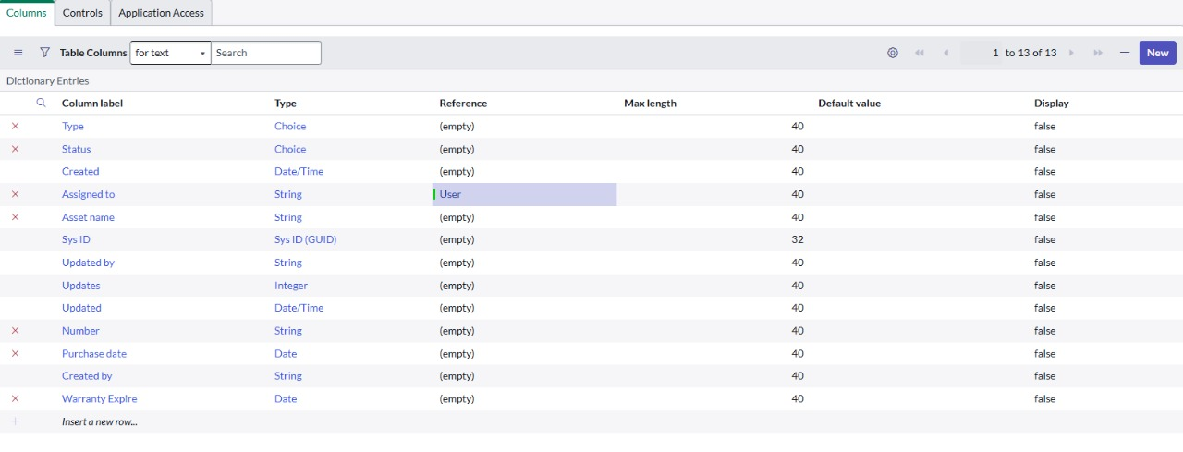
.
Milestone 4: Creation of UI Actions:
- Navigate to UI Actions under System Definition:
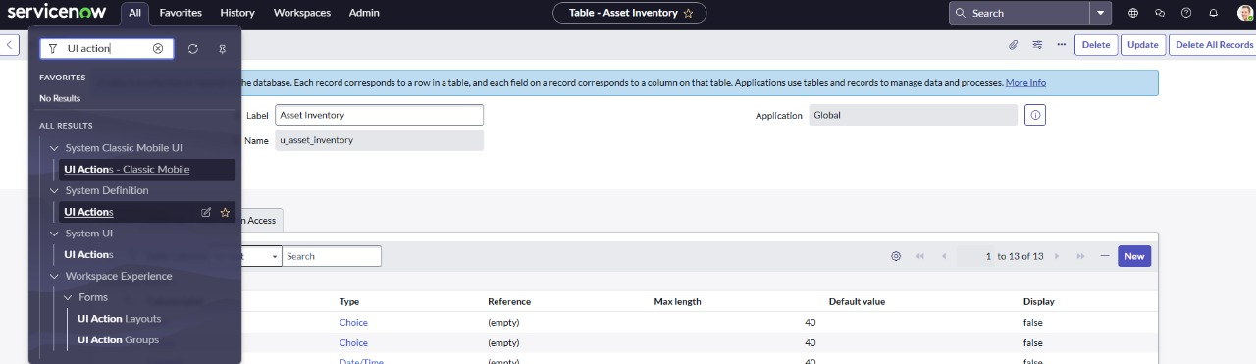
  - Click on new to create a new UI Action
  - Fill in the UI Action Details ;
  - Name: Mark as Lost
  - Table: Asset Inventory
  - Action name: mark_as_lost
  - Condition: current.u_status !=’Lost’
  - Update the script as
    - current.u_status = ‘Lost’;
current.update();
action.setRedirectURL(current);
  - Check the box Form Button to make it visible on the form layout.
  - Click Save to apply the changes.
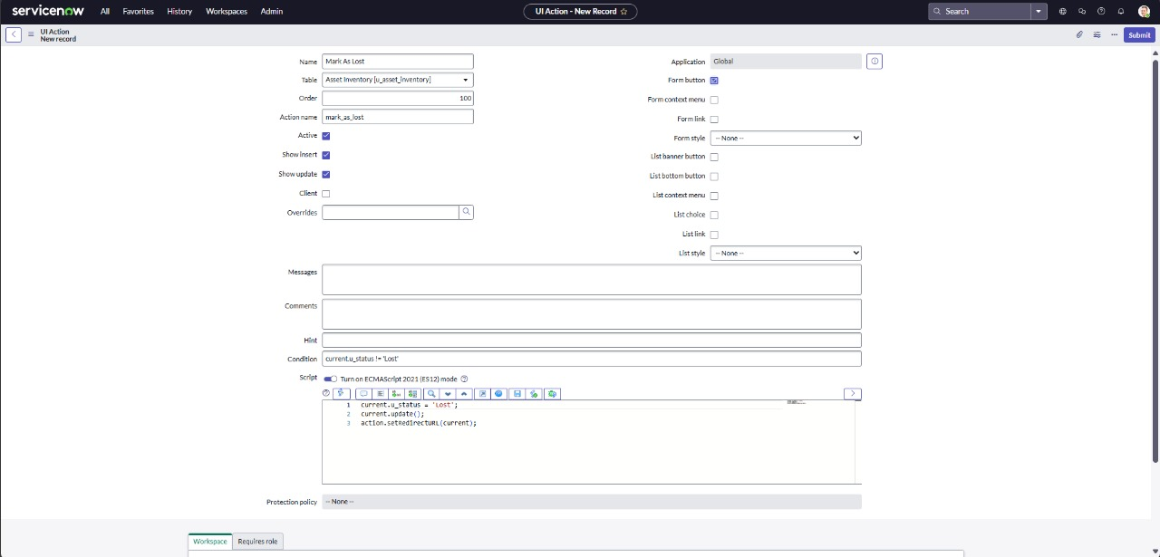

- Navigate to Application Navigator
  - Click on UI Actions under System Definition.
  - Click on New(top-right corner) to create new UI Action
  - Fill in the following details:
    - Name: Mark as Repaired
    - Table: Asset Inventory
    - Action name: mark_as_repaired
    - Condition: current.u_status==’Damaged’
  - Add the Script as:
    - current.u_status = ‘Available’;
current.update( );
action.setRedirectURL(current);
  - This Script updates the u_status field to Available saves the record, and then redirects the user back to the current record view.
  - Scroll down to the Form button section.
  - Check the box labeled Form button to ensure this action appears as a button on the form view.
  - Click on Submit to create the UI Action.
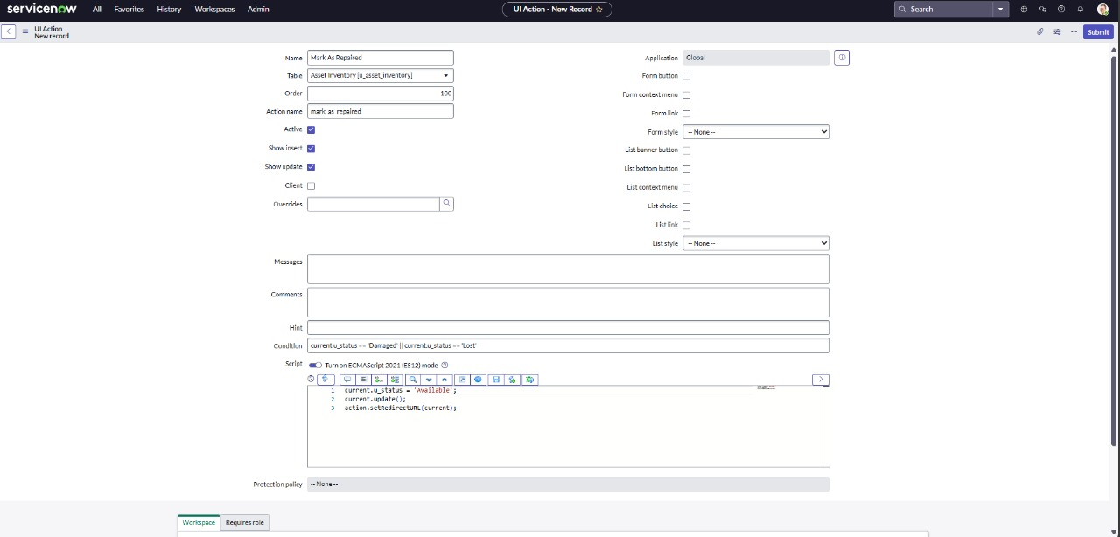
Milestone 5: Creation of Scheduled Job:
  - Navigate to All in the application navigator.
  - In the filter search bar, type Scheduled Job and select it from the list.
  - Click on the New button to create a new scheduled job.
  - Write the following script:
  - Enter the following details:
    - Name: Warranty Expiry Alert
    - Run : Daily
    - Time : 12:00
Write the following script:
var grAsset = new GlideRecord('u_asset_inventory'); // Replace with your table name
var today = new GlideDateTime();
var futureDate = new GlideDateTime();
futureDate.addDays(30); // Get date 30 days from now
grAsset.addQuery('u_warranty_expire', '<=', futureDate); // Warranty expiring within the next 30 days
grAsset.addQuery('u_warranty_expire', '>=', today); // Warranty expiring after today
grAsset.query();
while (grAsset.next()) {
var email = new GlideEmailOutbound();
email.setSubject("Warranty Expiry Alert: " + grAsset.getValue('u_assest_name')); // Use getValue for dynamic field access
email.setBody("The warranty for " + grAsset.getValue('u_assest_name') + " (Type: " + grAsset.getValue('u_asset_type') +
") is expiring soon on " + grAsset.getValue('u_warranty_expiry') + ". Please take action."); // Get values dynamically
email.setTo('it-support@company.com'); // Change to your IT support email
email.send();
gs.info("Email sent for assest: " + grAsset.getValue('u_assest_name')); // Log for confirmation
}
- Click Save to store the scheduled job.
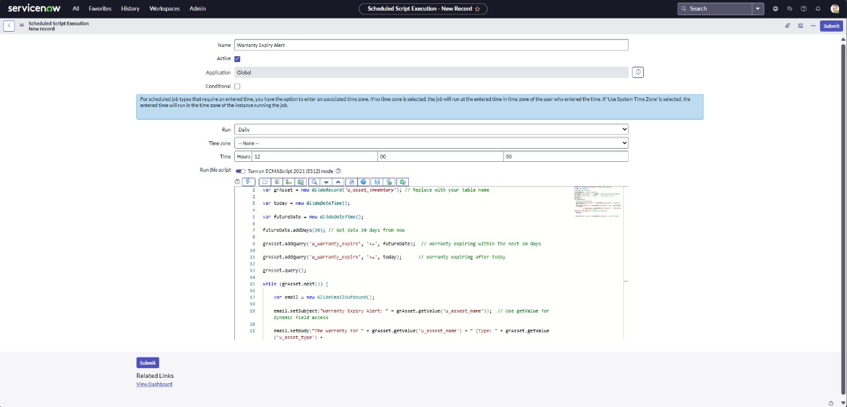
Milestone 6: Creation of Report :
  - Navigate to All in the main menu.
  - In the filter/search bar, type Reports, then select and open the Reports.
  - Click on the New button to create a new Report.
  - Enter the following details:
    - Report Name:Available vs assigned assets
    - Source Type: Table
    - Table: Asset Inventory
    - Type: Pie chart
    - Group By: Status
    - Aggregation: Count.
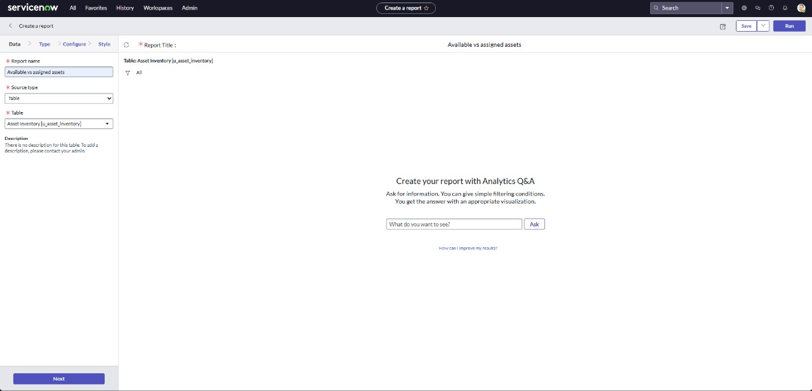
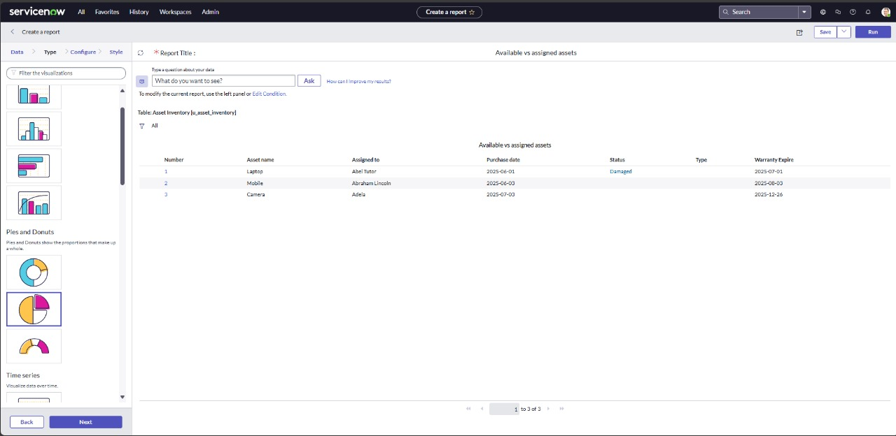
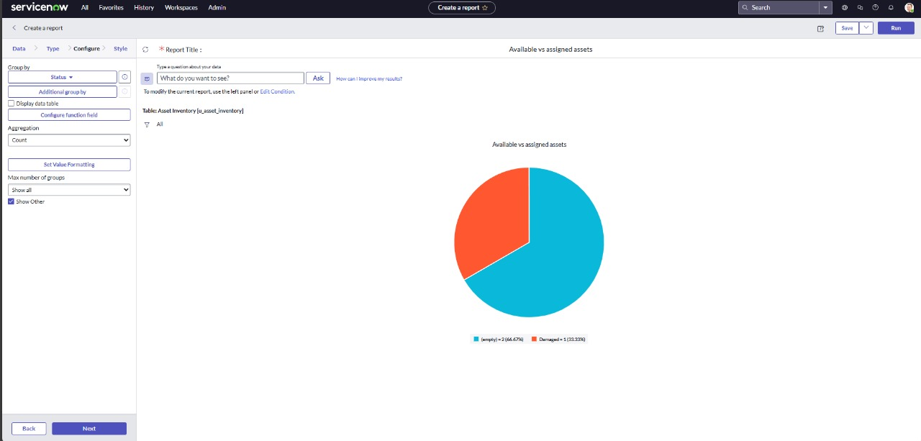
  - Click Save or Done (depending on the interface) to apply the changes.
  - Next click on run.
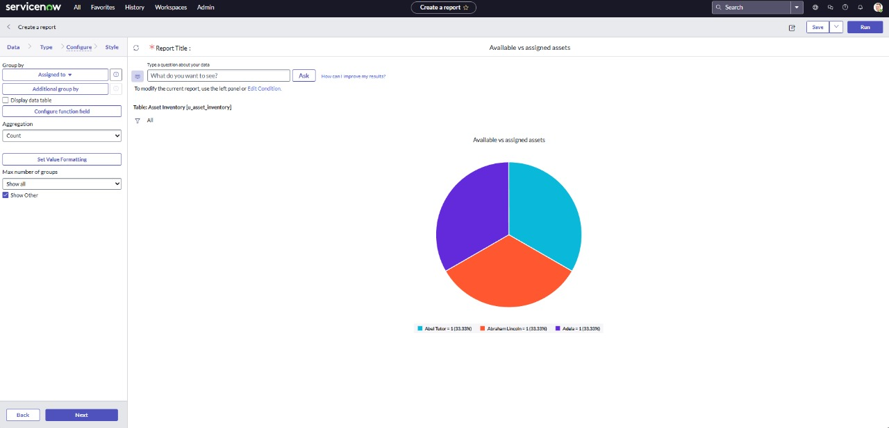

Milestone 7: Testing of UI Action:
  - From the main navigation, go to All.
  - In the search or filter bar, type Asset Inventory table.
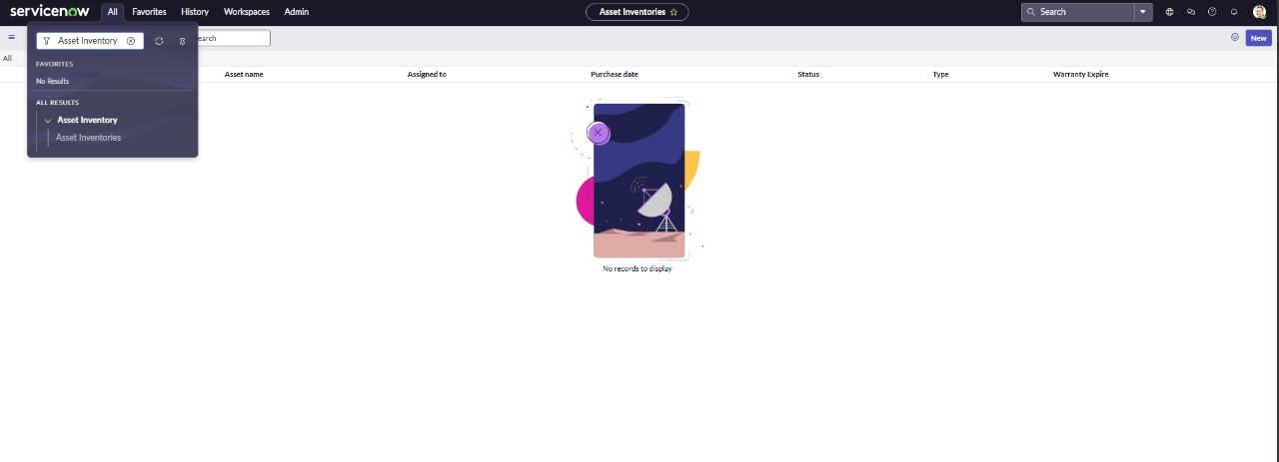
  - Click on the New button to test UI Action.
  - Fill in theAsset inventory table record Details:
    - Asset Name:Laptop
    - Type: laptop
    - Assigned to: Abel Tutor
    - Status: Available
    - Purchase date: 2025-06-01
    - Expiry date: 2025-07-01
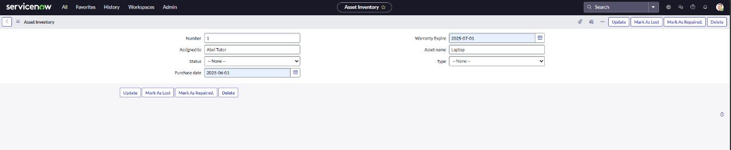
  - Click on Submit.
  - Open the record once again and click on the mark as lost button .
  - Save the record.
  - Check the status is changed to lost.
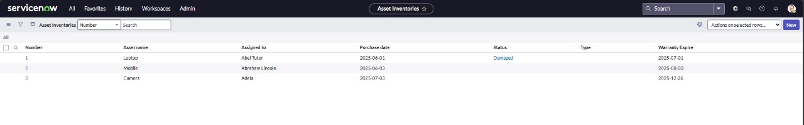
Milestone 8: Testing of Scheduled Job:
- From the main navigation, go to All.
- In the search bar, type background scripts, then open the Scheduled Job script in the background scripts.
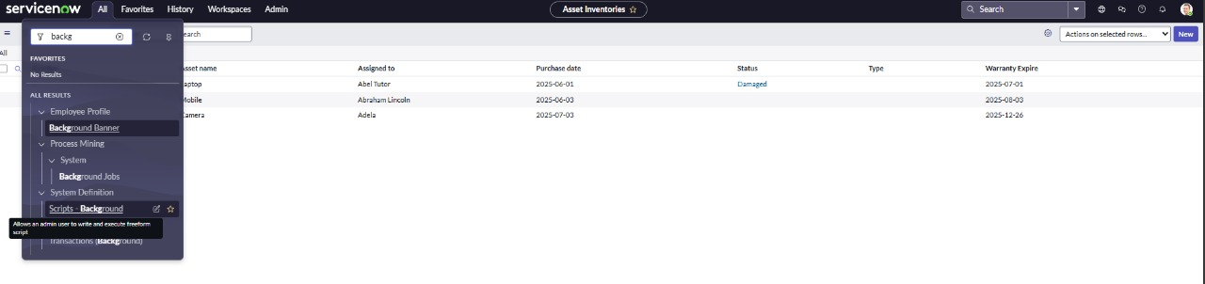
- Click on run script button to run the code.
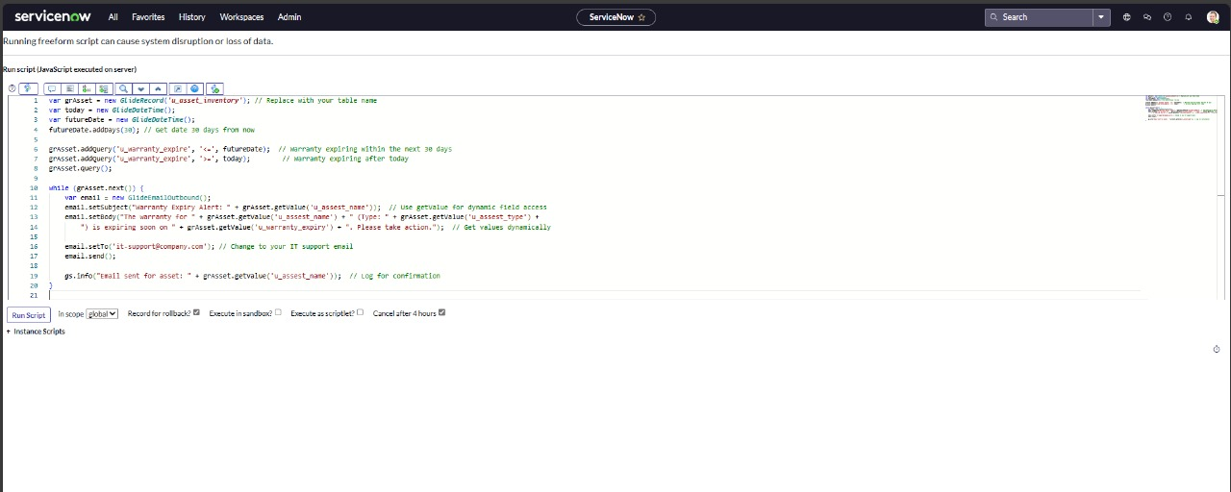
- After running the script, check the result.
